Aday in Kindergarten September Newsletter

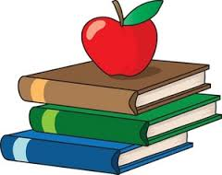

What’s New?

Here are some things we will be working on in the first month of kindergarten:

Writing/Reading Workshop: During our language arts block, we will begin the year by learning to recognize and write classmates’ names. We will be doing the same with days of the week, months of the year, and colors. Students will learn the letters in their name, and compare their names to others in the class. We will be starting our poem books, and will continue to add familiar poems and songs each week. By the end of the month, I will be launching reading and writing workshops.

Math: In math, the students will begin the year with counting numbers 0-10. We will also be collecting data and graphing in order to get to know our classmates (favorite colors, how many letters in first names, birthday months, etc).

Science/Social Studies: During science, we will be using our 5 senses to learn about weather changes that occur in the fall. We will explore the life cycle of apples and how they grow. In Social Studies, we will learn about the school community and school rules.

Check This Out!

- Back to school night/Early dismissal day: Tuesday, Sept. 19th (12:45 dismissal)
- No School: Sept. 21st & 22nd
- Please send in a smock for art class. It can be one bought from the store or an old t-shirt.
- If you are a “class parent” this year for our class, please contact me for a time to meet about parties/class events.
- Contact Info for Mrs. Aday:
adayc@riveredgeschools.org
call the school, or put a note in your childs’ folder.

Thank you!

