Aday in Kindergarten October Newsletter
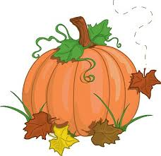

What’s New?

Now that students have become familiar with the daily routines of kindergarten, we will dive into our curriculum!

Writing/Reading Workshop: We have started writer’s workshop by organizing our writing folders and the writing tools we use. The first unit of study is personal narratives. This is when the children write stories about their own personal experiences (birthdays, holidays, play dates, sports or activities, family outings, etc.) I encourage the students to add labels or words to their illustrations. In reading workshop, the class has discussed why we read, where we read, and what we read. We will be learning to sit with a book and tell a story through the pictures, even if we cannot read the words yet. I will model using wordless picture books.

Math: In math, the students will be introduced to five frames/ten frames and use them to informally explore addition and subtraction. We will investigate 2D shapes and create shape patterns.

Science/Social Studies: During science, we will learn about the life cycle of apples and pumpkins. We will investigate how the sun warms the Earth, and various types of weather. In Social Studies, we will learn about fire safety. We will also explore the role of community helpers and their importance in the community (firefighters, police, mail carrier, doctor, etc.)

Check This Out!

- Oct. 9th: No School
- Oct. 11th Picture Day
- Oct. 31st Halloween Parade @ 1:30 on the RS Field (more info to follow)
- Scholastic Orders due 10/13/17 Online ordering code: HB3Z2
- Our Class Twitter:
@Aday_in_K
- Contact Info for Mrs. Aday:
adayc@riveredgeschools.org
call the school, or put a note in your childs’ folder.

